Mobile App Development (CIS4034-N)

Sprint Review
Completion Details
Name: | Karan Desai | Date: | 10/11/2025
Sprint number: | 2 | Tutor: | Julien Cordry
Introduction
The purpose of Sprint 2 was to begin developing the first functional user interface screens for the SmartBudget mobile application. While Sprint 1 focused on setting up Android Studio, GitHub, and the Trello board, Sprint 2 involved creating the initial UI flow of the app using Jetpack Compose. During this sprint, I designed and implemented the Splash Screen, Onboarding Screen, Login Screen, and Signup Screen, along with basic navigation logic between these screens.
Review Details
Which user stories were accepted by the Product Owner?
- As a developer, I designed and implemented the Splash Screen using Jetpack Compose.
- As a developer, I created the Onboarding Screen UI and added a navigation button to proceed to Login.
- As a developer, I developed the Login Screen and Signup Screen with email and password input fields.
- As a developer, I implemented basic navigation between all screens (splash, onboarding, login, signup).
- As a developer, I successfully ran all screens on the Android emulator and demonstrated them in class.
- As a developer, I kept my GitHub repository updated with frequent commits showing UI progress.
- As a developer, I updated my Trello board to show Sprint 2 tasks and workflow.

Which user stories were rejected by the Product Owner?

No User Stories were rejected
What feedback did the Product Owner give about the product and development team?
- The tutor approved the progress on the UI and confirmed that Sprint 2 meets the expected module requirements.
- He advised that the next sprint should include Firebase authentication and password validation rules.
- He asked for a placeholder home screen/dashboard to be added after successful login in Sprint 3.
- He reminded me to keep Trello and GitHub updated and to include screenshots as evidence.
What significant changes were made to the Product Backlog following the review?
- Added new backlog items for Sprint 3:
- Integrate Firebase Authentication.
- Add password validation rules (uppercase, lowercase, special character, length).
- Create placeholder Home Screen/Dashboard UI.
- Show error messages for invalid login or signup attempts.
- Design sidebar/bottom-bar navigation concept for the dashboard.
- Trello board updated to include Sprint 3 tasks.
- GitHub roadmap updated based on new requirement.
Were any security concerns identified during the sprint that had not been predicted?
- No sensitive data or authentication logic is handled in this sprint.
- Email/password fields are UI-only and do not store or transmit data.
- No external services (like Firebase) were used yet, keeping the app safe in early development.

Evidence
- UI working on emulator

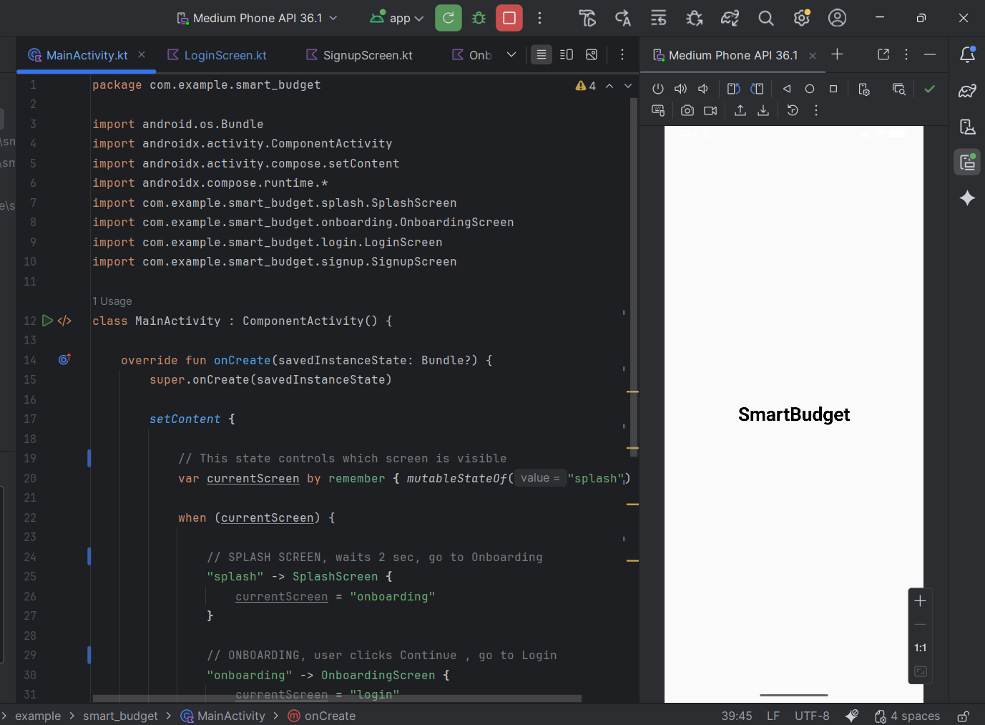

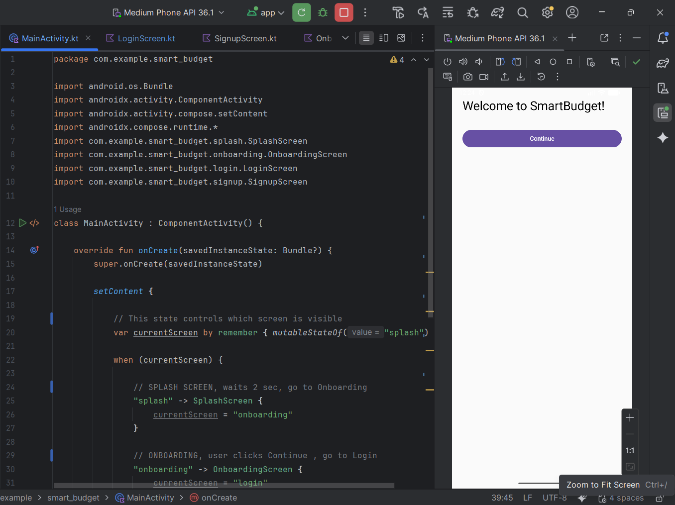

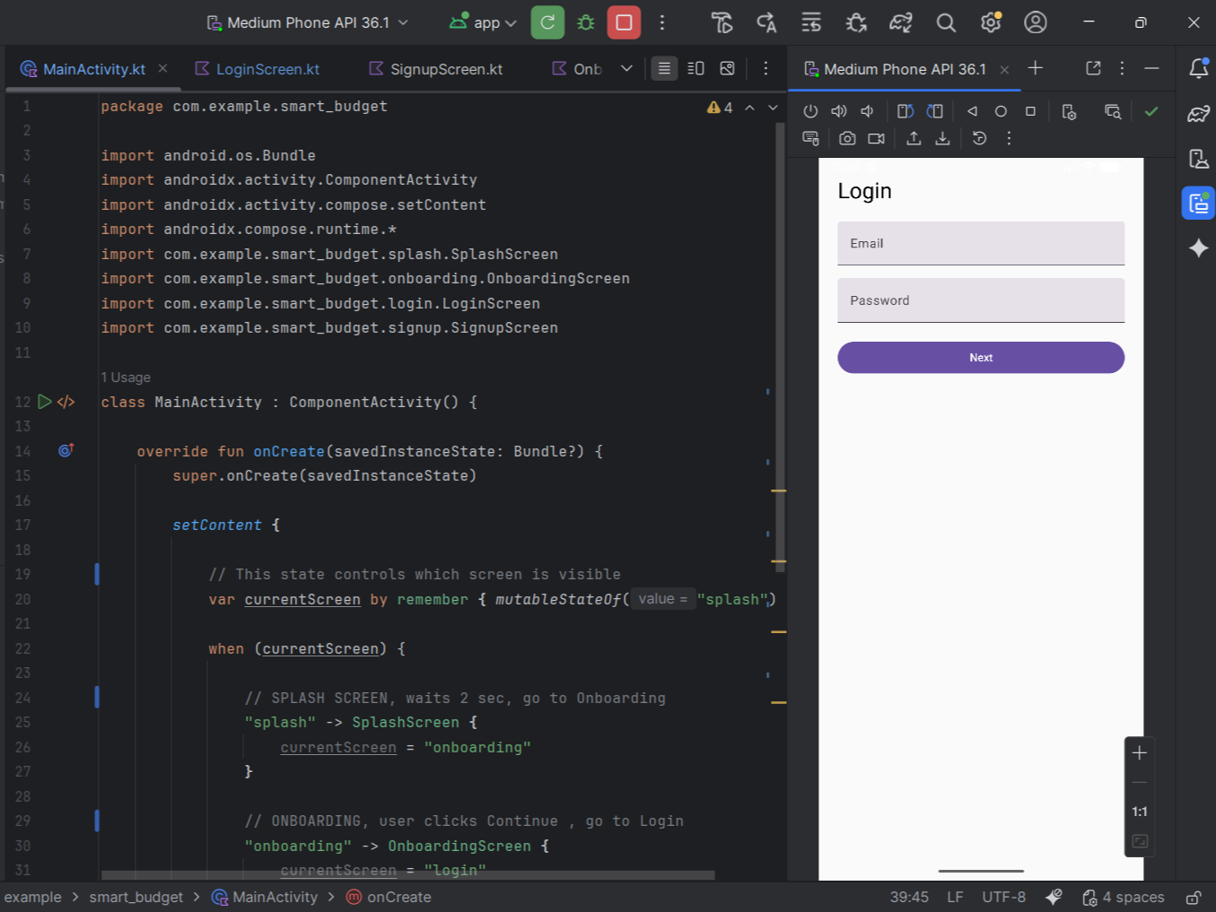
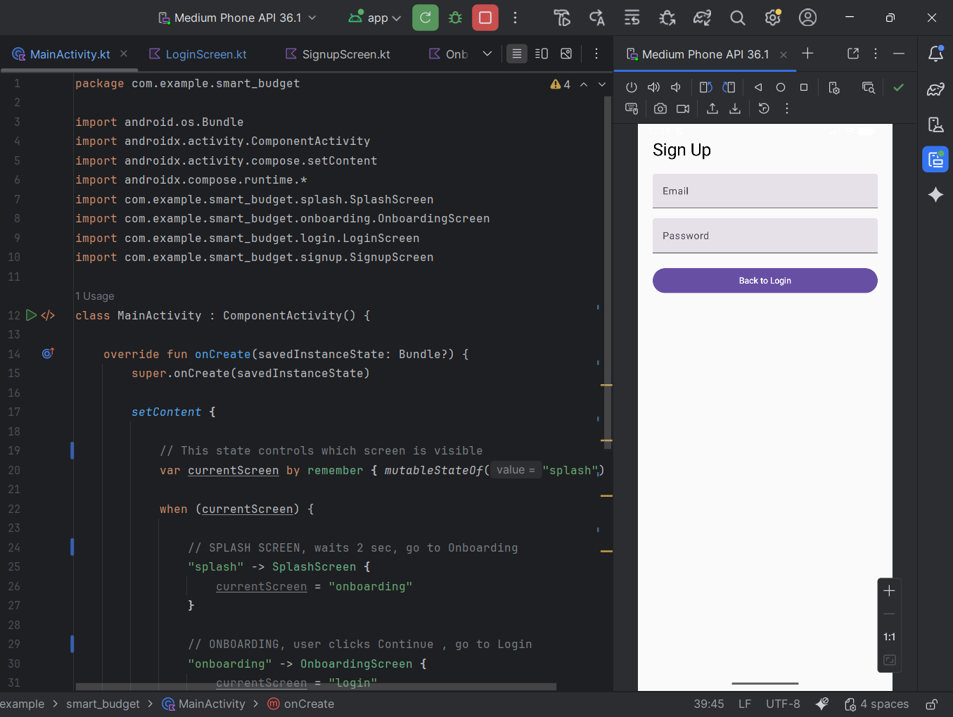

- Trello Board

